Package Title: Testbank
Course Title: PAP14
Chapter Number: 01

Question type: Multiple Choice

1) Which term describes the study of the functions of body structures?

a) anatomy
b) physiology
c) endocrinology
d) histology
e) immunology

Answer: b

Difficulty: Easy
Study Objective 1: SO 1.1 Define anatomy and physiology, and name several branches of these sciences.
Section Reference 1: Sec 1.1 Anatomy and Physiology Defined

2) Which term defines a group of cells that work together to perform a particular function?

a) tissue
b) organ
c) molecules
d) compounds
e) organism

Answer: a

Difficulty: Easy
Study Objective 1: SO 1.2 Identify the organ systems and major organs of the human body and describe their locations and functions.
Study Objective 2: SO 1.2.1 Describe the body’s six levels of structural organization.
Section Reference 1: Sec 1.2 Levels of Structural Organization and Body Systems.

3) Which term refers to the sum of all chemical processes that occur in the body?

a) metabolism
b) anabolism
c) catabolism
d) auscultation
e) palpation

Answer: a

Difficulty: Easy
Study Objective 1: SO 1.3.1 Define the important life processes of the human body.
Section Reference 1: Sec 1.3 Characteristics of the Living Human Organism

Question type: Essay

4) List the basic processes of life.

Answer:

Difficulty: Medium
Study Objective 1: SO 1.3.1 Define the important life processes of the human body.
Section Reference 1: Sec 1.3 Characteristics of the Living Human Organism
Solution: The basic processes of life include metabolism, responsiveness, movement, growth, differentiation and reproduction.

Question type: Multiple Choice

5) The two organ systems that regulate and maintain homeostasis are the

a) cardiovascular and integumentary systems.
b) nervous and endocrine systems.
c) cardiovascular and respiratory systems.
d) respiratory and muscular systems.
e) urinary and integumentary systems.

Answer: b

Difficulty: Easy
Study Objective 1: SO 1.4 Understand the importance of homeostatic feedback systems and how imbalances are related to disorders.
Study Objective 2: SO 1.4.1 Define homeostasis.
Section Reference 1: Sec 1.4 Homeostasis

6) Which body fluid fills the narrow spaces between cells and tissues and directly affects the proper functioning of cells?

a) lymph
b) blood plasma
c) interstitial fluid
d) intracellular fluid
e) vitreous body

Answer: c

Difficulty: Medium
Study Objective 1: SO 1.3 Define the important processes of the human body.
Study Objective 2: SO 1.3.2 Define homeostasis and explain its relationship to interstitial fluid.
Section Reference 1: Sec 1.3 Characteristics of the Living Human Organism

Question type: Essay

7) Describe the differences between positive and negative feedback systems.

Answer:

Difficulty: Medium
Study Objective 1: SO 1.4 Understand the importance of homeostatic feedback systems and how imbalances are related to disorders.
Study Objective 2: SO 1.4.3 Contrast the operation of negative and positive feedback systems.
Section Reference 1: Sec 1.4 Homeostasis
Solution: A positive feedback system will strengthen or reinforce a change in one of the body’s controlled conditions while a negative feedback system will reverse a change in a controlled condition.

Question type: Multiple Choice

8) Which feedback system structure receives output from the control center?

a) receptor
b) stimulus
c) response
d) effector
e) efferent pathway

Answer: d

Difficulty: Medium
Study Objective 1: SO 1.4 Understand the importance of homeostatic feedback systems and how imbalances are related to disorders.
Study Objective 2: SO 1.4.2 Describe the components of a feedback system.
Section Reference 1: Sec 1.4 Homeostasis

9) Which feedback system structure provides input to the control center?

a) receptor
b) muscle
c) response
d) effector
e) efferent pathway

Answer: a

Difficulty: Medium
Study Objective 1: SO 1.4 Understand the importance of homeostatic feedback systems and how imbalances are related to disorders.
Study Objective 2: SO 1.4.2 Describe the components of a feedback system.
Section Reference 1: Sec 1.4 Homeostasis

10) A condition NOT regulated by a negative feedback loop would be:

a) childbirth
b) body temperature
c) blood pressure
d) heart rate
e) blood sugar

Answer: a

Difficulty: Medium
Study Objective 1: SO 1.4 Understand the importance of homeostatic feedback systems and how imbalances are related to disorders.
Study Objective 2: SO 1.4.3 Contrast the operation of negative and positive feedback systems.
Section Reference 1: Sec 1.4 Homeostasis

11) Objective changes in a patient’s normal body function that can be directly observed or measured by a clinician are referred to as

a) symptoms.
b) disorders.
c) disturbance.
d) diseases
e) signs.

Answer: e

Difficulty: Medium
Study Objective 1: SO 1.4 Understand the importance of homeostatic feedback systems and how imbalances are related to disorders.
Study Objective 2: SO 1.4.4 Explain how homeostatic imbalances are related to disorders
Section Reference 1: Sec 1.4 Homeostasis

Question type: Essay

12) Describe the anatomical position.

Answer:

Difficulty: Medium
Study Objective 1: SO 1.5 Describe the human body using the anatomical position and specific anatomical terminology.
Study Objective 2: SO 1.5.1 Describe the anatomical position.
Section Reference 1: Sec 1.5 Basic Anatomical Terminology
Solution: In the anatomical position, the subject stands erect facing the observer with the head level and the eyes facing forward. The feet are flat on the floor and directed forward and the arms are at the sides with the palms turned forward.

Question type: Multiple Choice

13) The lungs are located in the

a) cranial cavity.
b) vertebral cavity.
c) abdominal cavity.
d) pericardial cavity.
e) pleural cavity.

Answer: e

Difficulty: Easy
Study Objective 1: SO 1.5 Describe the human body using the anatomical position and specific anatomical terminology.
Study Objective 2: SO 1.5.4 Outline the major body cavities, the organs they contain, and their associated linings.
Section Reference 1: Sec 1.5 Basic Anatomical Terminology

14) Which cavity is located inferior to the abdominal cavity?

a) vertebral canal
b) cranial cavity
c) abdominal cavity
d) pericardial cavity
e) pelvic cavity

Answer: e

Difficulty: Medium
Study Objective 1: SO 1.5 Describe the human body using the anatomical position and specific anatomical terminology.
Study Objective 2: SO 1.5.4 Outline the major body cavities, the organs they contain, and their associated linings.
Section Reference 1: Sec 1.5 Basic Anatomical Terminology

15) Which cavity contains the heart?

a) cranial cavity
b) vertebral cavity
c) abdominal cavity
d) pericardial cavity
e) pleural cavity

Answer: d

Difficulty: Easy
Study Objective 1: SO 1.5 Describe the human body using the anatomical position and specific anatomical terminology.
Study Objective 2: SO 1.5.4 Outline the major body cavities, the organs they contain, and their associated linings.
Section Reference 1: Sec 1.5 Basic Anatomical Terminology

16) The function of the secretions of a serous membrane, like the pleura, is to

a) separate the thoracic and abdominal cavities.
b) protect the central nervous system.
c) prevent infection.
d) reduce friction between neighboring organs.
e) carry nervous impulses.

Answer: d

Difficulty: Medium
Study Objective 1: SO 1.5 Describe the human body using the anatomical position and specific anatomical terminology.
Study Objective 2: SO 1.5.4 Outline the major body cavities, the organs they contain, and their associated linings.
Section Reference 1: Sec 1.5 Basic Anatomical Terminology

17) Which plane divides the body into equal right and left halves?

a) frontal
b) midsagittal
c) transverse
d) oblique
e) coronal

Answer: b

Difficulty: Medium
Study Objective 1: SO 1.5 Describe the human body using the anatomical position and specific anatomical terminology.
Study Objective 2: SO 1.5.3 Define the anatomical planes, anatomical sections, and directional terms used to describe the human body.
Section Reference 1: Sec 1.5 Basic Anatomical Terminology

18) Which plane divides the body into anterior and posterior portions?

a) frontal
b) sagittal
c) transverse
d) oblique
e) midsagittal

Answer: a

Difficulty: Medium
Study Objective 1: SO 1.5 Describe the human body using the anatomical position and specific anatomical terminology.
Study Objective 2: SO 1.5.3 Define the anatomical planes, anatomical sections, and directional terms used to describe the human body.
Section Reference 1: Sec 1.5 Basic Anatomical Terminology

19) A transverse plane will cut a body or organ into

a) anterior and posterior portions.
b) left and right portions.
c) superior and inferior portions.
d) portions separated at an angle to its longitudinal axis.
e) unequal left and right portions.

Answer: c

Difficulty: Medium
Study Objective 1: SO 1.5 Describe the human body using the anatomical position and specific anatomical terminology.
Study Objective 2: SO 1.5.3 Define the anatomical planes, anatomical sections, and directional terms used to describe the human body.
Section Reference 1: Sec 1.5 Basic Anatomical Terminology

20) Which directional term means farther from the midline?

a) medial
b) anterior
c) proximal
d) deep
e) lateral

Answer: e

Difficulty: Medium
Study Objective 1: SO 1.5 Describe the human body using the anatomical position and specific anatomical terminology.
Study Objective 2: SO 1.5.3 Define the anatomical planes, anatomical sections, and directional terms used to describe the human body.
Section Reference 1: Sec 1.5 Basic Anatomical Terminology

21) Which directional term means farther from the attachment of a limb to the trunk or farther from the origination of a structure?

a) deep
b) contralateral
c) lateral
d) cephalic
e) distal

Answer: e

Difficulty: Medium
Study Objective 1: SO 1.5 Describe the human body using the anatomical position and specific anatomical terminology.
Study Objective 2: SO 1.5.3 Define the anatomical planes, anatomical sections, and directional terms used to describe the human body.
Section Reference 1: Sec 1.5 Basic Anatomical Terminology

22) Choose the directional term that would make the following sentence correct. The heart is _____ to the liver.

a) inferior
b) anterior
c) contralateral
d) superior
e) superficial

Answer: d

Difficulty: Medium
Study Objective 1: SO 1.5 Describe the human body using the anatomical position and specific anatomical terminology.
Study Objective 2: SO 1.5.3 Define the anatomical planes, anatomical sections, and directional terms used to describe the human body.
Section Reference 1: Sec 1.5 Basic Anatomical Terminology

23) Choose the directional term that would make the following sentence correct. The sternum is _____ to the heart.

a) posterior
b) anterior
c) inferior
d) superior
e) lateral

Answer: b

Difficulty: Medium
Study Objective 1: SO 1.5 Describe the human body using the anatomical position and specific anatomical terminology.
Study Objective 2: SO 1.5.3 Define the anatomical planes, anatomical sections, and directional terms used to describe the human body.
Section Reference 1: Sec 1.5 Basic Anatomical Terminology

24) Which of the following organs is not found in the abdominal cavity?

a) stomach
b) spleen
c) liver
d) gallbladder
e) diaphragm

Answer: e

Difficulty: Medium
Study Objective 1: SO 1.5 Describe the human body using the anatomical position and specific anatomical terminology.
Study Objective 2: SO 1.5.4 Outline the major body cavities, the organs they contain, and their associated linings.
Section Reference 1: Sec 1.5 Basic Anatomical Terminology

25) Which serous membrane covers the viscera within the abdominal cavity, and lines the abdominal wall and the inferior surface of the diaphragm?

a) pericardium
b) pleura
c) mediastinum
d) dura mater
e) peritoneum

Answer: e

Difficulty: Medium
Study Objective 1: SO 1.5 Describe the human body using the anatomical position and specific anatomical terminology.
Study Objective 2: SO 1.5.4 Outline the major body cavities, the organs they contain, and their associated linings.
Section Reference 1: Sec 1.5 Basic Anatomical Terminology

26) Where on the diagram is the femoral area?
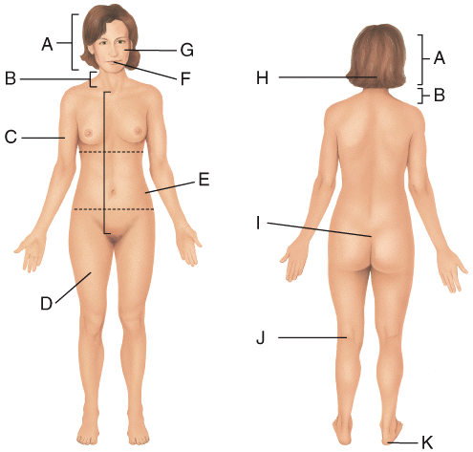

a) D
b) E
c) F
d) J
e) K

Answer: a

Difficulty: Medium
Study Objective 1: SO 1.5 Describe the human body using the anatomical position and specific anatomical terminology.
Study Objective 2: SO 1.5.3 Define the anatomical planes, anatomical sections, and directional terms used to describe the human body.
Section Reference 1: Sec 1.5 Basic Anatomical Terminology

27) Where on the diagram is the cervical area?

a) C
b) E
c) J
d) K
e) B

Answer: e

Difficulty: Medium
Study Objective 1: SO 1.5 Describe the human body using the anatomical position and specific anatomical terminology.
Study Objective 2: SO 1.5.3 Define the anatomical planes, anatomical sections, and directional terms used to describe the human body.
Section Reference 1: Sec 1.5 Basic Anatomical Terminology

28) The ribs are _____ to the sternum.
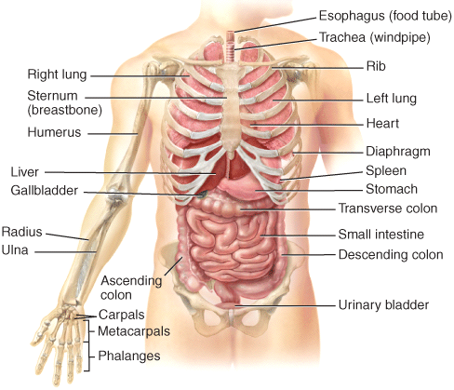

a) lateral
b) medial
c) proximal
d) distal
e) superior

Answer: a

Difficulty: Medium
Study Objective 1: SO 1.5 Describe the human body using the anatomical position and specific anatomical terminology.
Study Objective 2: SO 1.5.3 Define the anatomical planes, anatomical sections, and directional terms used to describe the human body.
Section Reference 1: Sec 1.5 Basic Anatomical Terminology

29) The stomach is _____ to the urinary bladder.

a) lateral
b) medial
c) distal
d) inferior
e) superior

Answer: e

Difficulty: Medium
Study Objective 1: SO 1.5 Describe the human body using the anatomical position and specific anatomical terminology.
Study Objective 2: SO 1.5.3 Define the anatomical planes, anatomical sections, and directional terms used to describe the human body.
Section Reference 1: Sec 1.5 Basic Anatomical Terminology

30) Which plane is parasagittal?
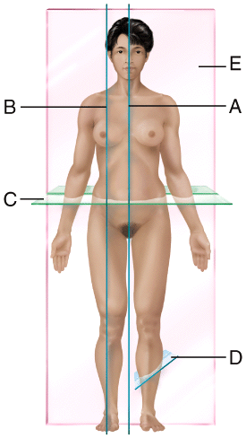

a) A
b) B
c) C
d) D
e) E

Answer: b

Difficulty: Medium
Study Objective 1: SO 1.5 Describe the human body using the anatomical position and specific anatomical terminology.
Study Objective 2: SO 1.5.3 Define the anatomical planes, anatomical sections, and directional terms used to describe the human body.
Section Reference 1: Sec 1.5 Basic Anatomical Terminology

31) Which plane is frontal?

a) A
b) B
c) C
d) D
e) E

Answer: e

Difficulty: Medium
Study Objective 1: SO 1.5 Describe the human body using the anatomical position and specific anatomical terminology.
Study Objective 2: SO 1.5.3 Define the anatomical planes, anatomical sections, and directional terms used to describe the human body.
Section Reference 1: Sec 1.5 Basic Anatomical Terminology

Question type: Essay

32) Name the cavities of the trunk and the serous membranes that line them.

Answer:

Difficulty: Medium
Study Objective 1: SO 1.5 Describe the human body using the anatomical position and specific anatomical terminology.
Study Objective 2: SO 1.5.4 Outline the major body cavities, the organs they contain, and their associated linings.
Section Reference 3: 1.5 Basic Anatomical Terminology
Solution: The two main cavities of the trunk are the thoracic and abdominopelvic cavities. The thoracic cavity can be divided into three smaller cavities called the pericardial cavity, and two fluid-filled spaces called pleural cavities. The pericardial cavity is lined by the pericardium. The pleural cavity is lined by the pleura. The central part of the thoracic cavity is an anatomical region called the mediastinum. It is between the lungs, extending from the sternum to the vertebral column and from the first rib to the diaphragm. The abdominopelvic cavity can be divided into the abdominal and pelvic cavities, both of which are lined by the peritoneum.

33) List the eleven organ systems of the human body.

Answer:

Difficulty: Medium
Study Objective 1: SO 1.2 Identify the organ systems and major organs of the human body and describe their locations and functions.
Study Objective 2: SO 1.2.2 List the 11 systems of the human body, representative organs present in each, and their general functions
Section Reference 1: Sec 1.2 Levels of Structural Organization body systems.
Solution: The eleven organ systems of the human body include the integumentary, skeletal, muscular, nervous, digestive, urinary, respiratory, immune and lymphatic, cardiovascular, endocrine, and reproductive systems.

34) Name the structural levels of the body and briefly describe each level.

Answer:

Difficulty: Hard
Study Objective 1: SO 1.2 Identify the organ systems and major organs of the human body and describe their locations and functions
Study Objective 2: SO 1.2.1 Describe the body’s six levels of structural organization.
Section Reference 1: Sec 1.2 Levels of Structural Organization body systems.
Solution: The chemical level consists of atoms and molecules. The cellular level consists of cells which are the smallest form of life. The tissue level consists of groups of cells that work to provide a single function. The organ level consists of organs, constructed from different types of tissue that can provide several different specific functions. The organ systems consist of one or more organs that are interlinked in general functions. The organism is made up of all the organ systems, which work to provide homeostasis.

35) List and briefly describe the six basic life processes.

Answer:

Difficulty: Hard
Study Objective 1: SO 1.3.1 Define the important life processes of the human body.
Section Reference 1: Sec 1.3 Characteristics of the Living Human Organism
Solution: The six basic life processes include: 1) Metabolism is the sum of all chemical processes in the body. 2) Responsiveness is the body’s ability to detect and respond to internal and external stimuli. 3) Movement includes motions that range from movements within individual cells to movement of the entire body. 4) Growth means an increase in body size or an increase in the number of cells. 5) Differentiation is the process that converts a cell from unspecialized to specialized. 6) Reproduction refers to formation of new cells for growth and repair or production of a new individual.

36) Describe a feedback system and list its general components.

Answer:

Difficulty: Medium
Study Objective 1: SO 1.4 Understand the importance of homeostatic feedback systems and how imbalances are related to disorders.
Study Objective 2: SO 1.4.2 Describe the components of a feedback system
Section Reference 1: Sec 1.4 Homeostasis
Solution: A feedback loop is a cycle of events in which the status of the body condition is monitored, evaluated and changed to maintain homeostasis. A feedback system will include a receptor that detects the stimuli, a control center that receives the input from the receptor and generates an output, and an effector that receives the output and produces a response.

Question type: Multiple Choice

37) Which of the following noninvasive diagnostic techniques is an example of inspection?

a) tapping and listening for an echo to detect fluid in the lungs
b) feeling the abdomen to detect tender organs
c) listening for crackling sounds during breathing
d) examining the surface of patient’s skin for presence of a rash
e) feeling the gonads to detect abnormal masses

Answer: d

Difficulty: Hard
Study Objective 1: SO 1.2 Identify the organ systems and major organs of the human body and describe their locations and functions.
Study Objective 2: SO 1.2.2 List the 11 systems of the human body, representative organs present in each, and their general functions.
Section Reference 1: Sec 1.2 Levels of Structural Organization body systems.

38) Which subspecialty of physiology deals with the study of the functional properties of nerve cells?

a) endocrinology
b) cardiovascular physiology
c) neurophysiology
d) immunology
e) pathophysiology

Answer: c

Difficulty: Easy
Study Objective 1: SO 1.1 Define anatomy and physiology, and name several branches of these sciences.
Section Reference 1: Sec 1.1 Anatomy and Physiology Defined

39) Which subspecialty of physiology deals with the study of the chemical regulators in the blood?

a) endocrinology
b) cardiovascular physiology
c) neurophysiology
d) immunology
e) pathophysiology

Answer: a

Difficulty: Easy
Study Objective 1: SO 1.1 Define anatomy and physiology, and name several branches of these sciences.
Section Reference 1: Sec 1.1 Anatomy and Physiology Defined

40) Which subspecialty of physiology deals with the study of functional changes associated with disease and aging?

a) exercise physiology
b) renal physiology
c) pathophysiology
d) cardiovascular physiology
e) immunology

Answer: c

Difficulty: Easy
Study Objective 1: SO 1.1 Define anatomy and physiology, and name several branches of these sciences.
Section Reference 1: Sec 1.1 Anatomy and Physiology Defined

41) Which subspecialty of physiology deals with the study of the body’s defense against disease-causing agents?

a) exercise physiology
b) renal physiology
c) pathophysiology
d) cardiovascular physiology
e) immunology

Answer: e

Difficulty: Easy
Study Objective 1: SO 1.1 Define anatomy and physiology, and name several branches of these sciences.
Section Reference 1: Sec 1.1 Anatomy and Physiology Defined

42) Which subspecialty of anatomy deals with the study of structural changes associated with disease?

a) embryology
b) developmental biology
c) radiographic anatomy
d) pathological anatomy
e) immunology

Answer: d

Difficulty: Medium
Study Objective 1: SO 1.1 Define anatomy and physiology, and name several branches of these sciences.
Section Reference 1: Sec 1.1 Anatomy and Physiology Defined

43) Which of the following anatomical terms refers to the groin?

a) pelvic
b) umbilical
c) sternal
d) otic
e) inguinal

Answer: e

Difficulty: Medium
Study Objective 1: SO 1.5 Describe the human body using the anatomical position and specific anatomical terminology.
Study Objective 2: SO 1.5.2 Relate the anatomical names and the corresponding common names for various regions of the human body.
Section Reference 1: Sec 1.5 Basic Anatomical Terminology

44) Which of the following anatomical terms refers to the front of the elbow?

a) olecranal
b) antecubital
c) carpal
d) digital
e) antebrachial

Answer: b

Difficulty: Hard
Study Objective 1: SO 1.5 Describe the human body using the anatomical position and specific anatomical terminology.
Study Objective 2: SO 1.5.2 Relate the anatomical names and the corresponding common names for various regions of the human body.
Section Reference 1: Sec 1.5 Basic Anatomical Terminology

45) Which of the following anatomical terms refers to the ear?

a) otic
b) orbital
c) ocular
d) oral
e) occipital

Answer: a

Difficulty: Hard
Study Objective 1: SO 1.5 Describe the human body using the anatomical position and specific anatomical terminology.
Study Objective 2: SO 1.5.2 Relate the anatomical names and the corresponding common names for various regions of the human body.
Section Reference 1: Sec 1.5 Basic Anatomical Terminology

46) Which of the following anatomical terms refers to the great toe?

a) pollex
b) tarsal
c) hallux
d) pedal
e) carpal

Answer: c

Difficulty: Hard
Study Objective 1: SO 1.5 Describe the human body using the anatomical position and specific anatomical terminology.
Study Objective 2: SO 1.5.2 Relate the anatomical names and the corresponding common names for various regions of the human body.
Section Reference 1: Sec 1.5 Basic Anatomical Terminology

47) Which of the following anatomical terms refers to the thumb?

a) pollex
b) tarsal
c) hallux
d) volar
e) carpal

Answer: a

Difficulty: Hard
Study Objective 1: SO 1.5 Describe the human body using the anatomical position and specific anatomical terminology.
Study Objective 2: SO 1.5.2 Relate the anatomical names and the corresponding common names for various regions of the human body.
Section Reference 1: Sec 1.5 Basic Anatomical Terminology

48) The section shown in (c) results from cutting through a _____ plane extending through the brain?
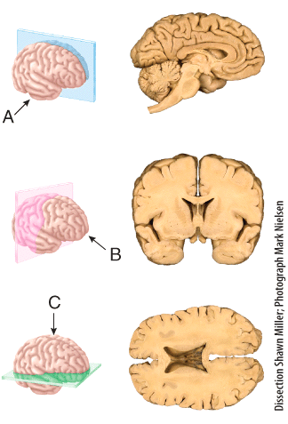

a) frontal
b) sagittal
c) oblique
d) midsagittal
e) transverse

Answer: e

Difficulty: Medium
Study Objective 1: SO 1.5 Describe the human body using the anatomical position and specific anatomical terminology.
Study Objective 2: SO 1.5.2 Relate the anatomical names and the corresponding common names for various regions of the human body .
Section Reference 1: Sec 1.5 Basic Anatomical Terminology

49) The section shown in (b) results from cutting through a _______ plane extending through the brain?

a) frontal
b) sagittal
c) oblique
d) midsagittal
e) transverse

Answer: a

Difficulty: Medium
Study Objective 1: SO 1.5 Describe the human body using the anatomical position and specific anatomical terminology.
Study Objective 2: SO 1.5.2 Relate the anatomical names and the corresponding common names for various regions of the human body.
Section Reference 1: Sec 1.5 Basic Anatomical Terminology

50) Which cavity contains the small intestine?
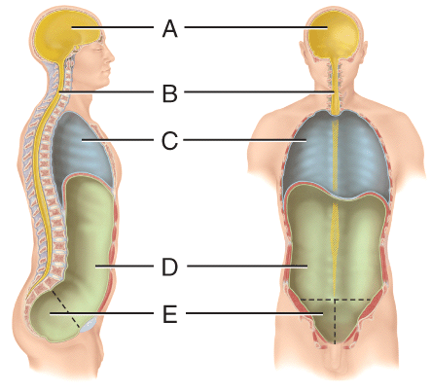

a) (A)
b) (B)
c) (C)
d) (D)
e) (E)

Answer: d

Difficulty: Easy
Study Objective 1: SO 1.5 Describe the human body using the anatomical position and specific anatomical terminology.
Study Objective 2: SO 1.5.2 Relate the anatomical names and the corresponding common names for various regions of the human body.
Section Reference 1: Sec 1.5 Basic Anatomical Terminology

51) Which cavity contains the liver?

a) (A)
b) (B)
c) (C)
d) (D)
e) (E)

Answer: d

Difficulty: Easy
Study Objective 1: SO 1.5 Describe the human body using the anatomical position and specific anatomical terminology.
Study Objective 2: SO 1.5.2 Relate the anatomical names and the corresponding common names for various regions of the human body.
Section Reference 1: Sec 1.5 Basic Anatomical Terminology

52) Which contains the spinal cord?

a) (A)
b) (B)
c) (C)
d) (D)
e) (E)

Answer: b

Difficulty: Easy
Study Objective 1: SO 1.5 Describe the anatomical position and how anatomical terms are used to describe the human body.
Study Objective 2: SO 1.5.4 Outline the major body cavities, the organs they contain, and their associated linings.
Section Reference 1: Sec 1.5 Basic Anatomical Terminology

53) Which cavity contains the internal organs of reproduction?

a) (A)
b) (B)
c) (C)
d) (D)
e) (E)

Answer: e

Difficulty: Easy
Study Objective 1: SO 1.5 Describe the anatomical position and how anatomical terms are used to describe the human body.
Study Objective 2: SO 1.5 4 Outline the major body cavities, the organs they contain, and their associated linings.
Section Reference 1: Sec 1.5 Basic Anatomical Terminology

54) What is the name of the serous membrane in closest proximity to the lungs?

a) parietal pleura
b) visceral pleura
c) parietal pericardium
d) visceral pericardium
e) mediastinum

Answer: b

Difficulty: Medium
Study Objective 1: SO 1.5 Describe the human body using the anatomical position and specific anatomical terminology.
Study Objective 2: SO 1.5.4 Outline the major body cavities, the organs they contain, and their associated linings.
Section Reference 1: Sec 1.5 Basic Anatomical Terminology

55) What is the name of the outer layer of the serous membrane that surrounds the heart?

a) diaphragm
b) visceral pleura
c) parietal pericardium
d) visceral pericardium
e) mediastinum

Answer: c

Difficulty: Medium
Study Objective 1: SO 1.5 Describe the human body using the anatomical position and specific anatomical terminology.
Study Objective 2: SO 1.5.4 Outline the major body cavities, the organs they contain, and their associated linings.
Section Reference 1: Sec 1.5 Basic Anatomical Terminology

56) Which region is the epigastric region?
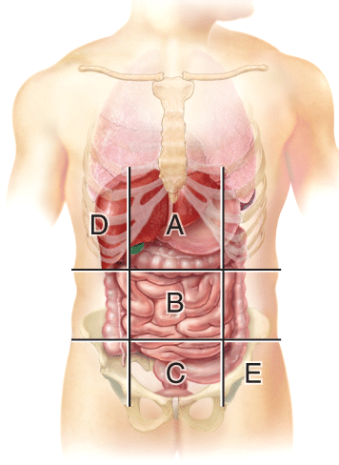

a) (A)
b) (B)
c) (C)
d) (D)
e) (E)

Answer: a

Difficulty: Easy
Study Objective 1: SO 1.5 Describe the human body using the anatomical position and specific anatomical terminology.
Study Objective 2: SO 1.5.4 Outline the major body cavities, the organs they contain, and their associated linings.
Section Reference 1: Sec 1.5 Basic Anatomical Terminology

57) Which region is the hypogastric region?

a) (A)
b) (B)
c) (C)
d) (D)
e) (E)

Answer: c

Difficulty: Easy
Study Objective 1: SO 1.5 Describe the anatomical position and how anatomical terms are used to describe the human body.
Study Objective 2: SO 1.5.4 Outline the major body cavities, the organs they contain, and their associated linings.
Section Reference 1: Sec 1.5 Basic Anatomical Terminology

58) Which radiographs were obtained using low-dose x-rays?
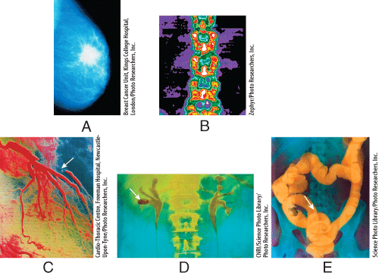

a) (A) and (B)
b) (B) and (C)
c) (C) and (D)
d) (A) and (C)
e) (B) and (E)

Answer: a

Difficulty: Hard
Study Objective 1: SO 1.6 Describe the principles and importance of medical imaging procedures in the evaluation of organ functions and the diagnosis of disease.
Section Reference 1: Sec 1.6 Medical Imaging

Question type: Essay

59) Discuss the importance of body fluids and which one is considered to be the body’s internal environment.

Answer:

Difficulty: Medium
Study Objective 1: SO 1.3 Define the important processes.
Learning Objective 2 LO 1.3.2 Define homeostasis and explain its relationship to interstitial fluid.
Section Reference 1: Sec 1.4 Homeostasis
Solution: An important aspect of homeostasis is maintaining the volume and composition of body fluids, which are dilute, watery solutions containing the dissolved substances needed to sustain life. The fluid within cells is intracellular fluid (ICF) and the fluid found outside of cells is extracellular fluid (ECF). The ECF consists of interstitial fluid, blood plasma, lymph, cerebrospinal fluid, synovial fluid, aqueous humor, and vitreous. The ECF called interstitial fluid, which is the fluid found in the narrow spaces between cells and tissues, is also known as the body’s internal environment. This is due to the fact that the proper functioning of body cells depends on precise regulation of the composition of the interstitial fluid surrounding them.

Question type: Multiple Choice

60) Which of the following is an example of the basic life process called growth?
1. muscle contraction
2. digestion of proteins
3. lifting weights and gaining muscle mass
4. mineral deposits accumulating between bone cells to cause a bone to lengthen

a) 1 only
b) 2 only
c) 3 only
d) 4 only
e) 3 and 4

Answer: e

Difficulty: Hard
Study Objective 1: SO 1.3 Define the important processes of the human body.
Study Objective 2: SO 1.3.1 Define the important life processes of the human body.
Section Reference 1: Sec 1.3 Characteristics of the Living Human Organism

61) Feeling the presence of a mosquito biting your arm is an example of

a) growth.
b) movement.
c) responsiveness.
d) reproduction.
e) differentiation.

Answer: c

Difficulty: Easy
Study Objective 1: SO 1.3 Define the important life processes.
Study Objective 2: SO 1.3.1 Define the important life processes of the human body.
Section Reference 1: Sec 1.3 Characteristics of the Living Human Organism

62) During a visit to your doctor, you complain about headache and nausea. These changes in your body functions are considered to be

a) signs.
b) symptoms.
c) pharmacology.
d) controlled condition.
e) epidemiology.

Answer: b

Difficulty: Easy
Study Objective 1: SO 1.4 Understand the importance of homeostatic feedback systems and how imbalances are related to disorders.
Study Objective 1: SO 1.4.4 Explain how homeostatic imbalances are related to disorders.
Section Reference 1: Sec 1.4 Homeostasis

63) An embryonic stem cell undergoes _____ to become a neuron.

a) catabolism
b) growth
c) reproduction
d) anabolism
e) differentiation

Answer: e

Difficulty: Medium
Study Objective 1: SO 1.3 Define the important processes of the human body
Study Objective 2: SO 1.3.1 Define the important life processes of the human body.
Section Reference 1: Sec 1.3 Characteristics of the Living Human Organism

64) Which of the following describes a body process that is controlled using a positive feedback loop?

a) increasing body temperature in response to a drop in body temperature
b) decreasing body temperature in response to elevated body temperature
c) decreasing blood [glucose] in response to elevated blood [glucose]
d) increasing strength of uterine contractions in response to cervical stretch
e) decreasing heart rate in response to elevated blood pressure

Answer: d

Difficulty: Hard
Study Objective 1: SO 1.4 Understand the importance of homeostatic feedback systems and how imbalances are related to disorders.
Study Objective 2: SO 1.4.3 Contrast the operation of negative and positive feedback systems.
Section Reference 1: Sec 1.4 Homeostasis

65) Which of the following organs contains the control center for the feedback system that regulates blood pressure?

a) skin
b) arteries
c) brain
d) heart
e) pituitary gland

Answer: c

Difficulty: Medium
Study Objective 1: SO 1.4 Understand the importance of homeostatic feedback systems and how imbalances are related to disorders.
Study Objective 2: SO 1.4.2 Describe the components of a feedback system.
Section Reference 1: Sec 1.4 Homeostasis

66) Which of the following is NOT a common characteristic of a negative feedback system?

a) regulates conditions in body that remain fairly stable over long periods
b) important in maintaining homeostasis
c) involves control centers in the nervous or endocrine systems
d) stimulates changes that reverse the direction of the stimulus
e) usually requires an event outside the feedback system to shut it off

Answer: e

Difficulty: Hard
Study Objective 1: SO 1.4 Understand the importance of homeostatic feedback systems and how imbalances are related to disorders.
Study Objective 2: SO 1.4.3 Contrast the operation of negative and positive feedback systems.
Section Reference 1: Sec 1.4 Homeostasis

67) Which of the following represents the largest and most complex level of structural organization in the human body?

a) chemical level
b) cellular level
c) tissue level
d) organ level
e) organismal level

Study Objective 1: SO 1.2 Identify the organs systems and major organs of the human body and describe their locations and functions.
Study Objective 2: SO 1.2.1 Describe the body’s six levels of structural organization.
Section Reference 1: Sec 1.2 Levels of Structural Organization body systems.

68) Which of the following is NOT one of the four basic types of tissues found in the human body?

a) epithelial tissue
b) connective tissue
c) muscular tissue
d) necrotic tissue
e) nervous tissue

Answer: d

Difficulty: Easy
Study Objective 1: SO 1.2 Identify the organ systems and major organs of the human body and describe their locations and functions.
Study Objective 2: SO 1.2.1 Describe the body’s six levels of structural organization.
Section Reference 1: Sec 1.2 Levels of Structural Organization and Body Systems.

69) Which of the following correctly list the levels of structural organization in the human body from largest to smallest?

a) chemical - cellular - tissue - organ - organ system - organism
b) cellular - chemical - tissue - organ - organ system - organism
c) organism - organ system - organ - tissue - cellular - chemical
d) organ - organ system - organism - tissue - cellular - chemical
e) tissue - cellular - organ - organ system - organism - chemical

Answer: c

Difficulty: Easy
Study Objective 1: SO 1.2 Identify the organ systems and major organs of the human body and describe their locations and functions.
Study Objective 2: SO 1.2.1 Describe the body’s six levels of structural organization.
Section Reference 1: Sec 1.2 Levels of Structural Organization body systems.

70) Which of the following structures or regions could you clearly see when you are viewing the anterior side of an individual standing in the standard anatomical position?

a) shoulder blade
b) palm of the hand
c) plantar surface of foot
d) popliteal region of the knee
e) gluteal region

Answer: b

Difficulty: Medium
Study Objective 1: SO 1.5 Describe the human body using the anatomical position and specific anatomical terminology.
Study Objective 2: SO 1.5.1 Describe the anatomical position.
Section Reference 1: Sec 1.5 Basic Anatomical Terminology

71) Which of the following structures or regions could you clearly see when you are viewing the anterior side of an individual standing in the standard anatomical position?

a) shoulder blade
b) palm of the hand
c) plantar surface of foot
d) popliteal region of the knee
e) gluteal region

Answer: b

Difficulty: Medium
Study Objective 1: SO 1.5 Describe the human body using the anatomical position and specific anatomical terminology.
Study Objective 2: SO 1.5.1 Describe the anatomical position.
Section Reference 1: Sec 1.5 Basic Anatomical Terminology

72) Which of the following is a safe non-invasive imaging technique that uses the reflection of high frequency sound waves off of body tissues to visualize a fetus during pregnancy?

a) computed tomography
b) magnetic resonance imaging
c) ultrasound scanning
d) radionuclide scanning
e) amniocentesis

Answer: c

Difficulty: Easy
Study Objective 1: SO 1.6 Describe the principles and importance of medical imaging procedures in the evaluation of organ functions and the diagnosis of disease.
Section Reference 1: Sec 1.6 Medical Imaging

73) Mammography and bone densitometry are good examples of which of the following types of medical imaging?

a) computed tomography
b) magnetic resonance imaging
c) ultrasound scanning
d) radionuclide scanning
e) low-dose radiography

Answer: e

Difficulty: Easy
Study Objective 1: SO 1.6 Describe the principles and importance of medical imaging procedures in the evaluation of organ functions and the diagnosis of disease.
Section Reference 1: Sec 1.6 Medical Imaging

74) Which of the following is a safe non-invasive imaging technique that uses the reflection of high frequency sound waves off of body tissues to visualize a fetus during pregnancy?

a) computed tomography
b) magnetic resonance imaging
c) ultrasound scanning
d) radionuclide scanning
e) amniocentesis

Answer: c

Difficulty: Easy
Study Objective 1: SO 1.6 Describe the principles and importance of medical imaging procedures in the evaluation of organ functions and the diagnosis of disease.
Section Reference 1: Sec 1.6 Medical Imaging

75) Mammography and bone densitometry are good examples of which of the following types of medical imaging.

a) computed tomography
b) magnetic resonance imaging
c) ultrasound scanning
d) radionuclide scanning
e) low-dose radiography

Answer: e

Difficulty: Easy
Study Objective 1: SO 1.6 Describe the principles and importance of medical imaging procedures in the evaluation of organ functions and the diagnosis of disease.
Section Reference 1: Sec 1.6 Medical Imaging

